Copied from AZ CSC
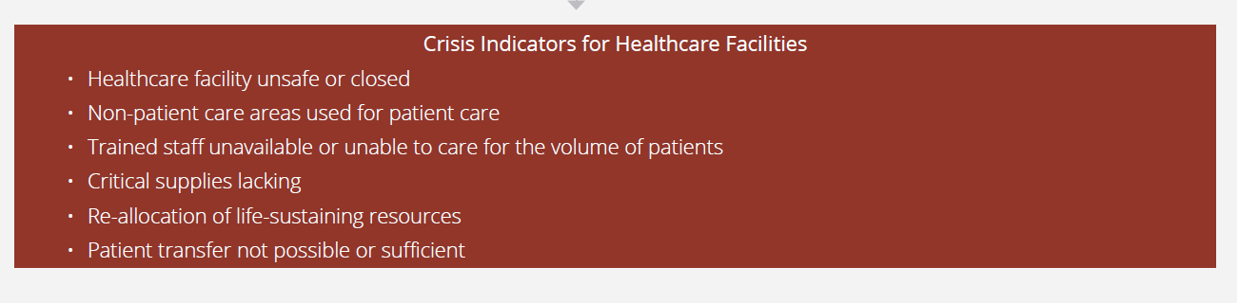

What facility metrics do we need to document internally
Here are examples of indicators of the Crisis Levels of Care. These represent the way you deliver care during the pandemic and how this may vary from the normal/expected/usual (Conventional) standards. These are things you would NOT have done prior to the pandemic but are necessary to provide care and do the most good. Examples of these indicators are listed below. Only one indicator is necessary to meet the definition of the Crisis Level Standards.
Examples
- Healthcare facility unsafe or closed
  - Closed or on diversion obvious
Unsafe: patients in hallways, obscuring fire doors, “rigging” equipment >
    - The type of things you would normally consider safety violations
- Non-patient care areas used for patient care
  - Where are you putting patients that you don’t usually:
    - Auditoriums? Hallways? Offices? ORs? Medical office buildings attached to hospitals?
- Trained staff unavailable or unable to care for the volume of patients
  - Who don’t you have or have enough of?
    - Specialist physicians
    - Hospitalists
    - Staff
  - Do you need to expand the scope of clinicians to provide the care necessary?
    - Anesthesia or Surgery as intensivist
  - Are your staffing ratios not consistent with Conventional Standards?
    - Physicians, Nurses, Ancillary and Support.
- Critical supplies lacking
What do you need and don’t have or don’t have enough?
- Ventilators
- Oxygen
- GlideScopes
- IV supplies and fluids
- Specialized beds
- Pharmaceuticals
  - Sedatives(Propofol)
  - Antivirals
  - Corticosteroids
  - Pressors
- PPE
Do you need to repurpose to provide care?
- Eg: Ventilators
- Allocation and Re-allocation of life-sustaining resources:
  - Medications
  - ICU beds
  - Ventilators
  - Hospital admission
- Patient transfer not possible or insufficient to meet patient needs
  - Can you get patients where they need to go in the time that makes medical sense?
  - Can you transfer to higher level of care when required? Lower level?
    - Neurosurgery, transplant, ECMO, ICU, others?
  - Are there significant delays that impact the patients care plan and outcome?

